**MEDSHARE – A Medicine Sharing App**

**PROJECT REPORT**

*Submitted by*

AMBARISH MANNA (23BCS11948)

RUCHI SHARMA (23BCS10713)

RISHIKA PAUL (23BCS10869)

SANDIP PAN (23BCS13539)

***in partial fulfilment for the award of the degree of***

**Bachelors of Engineering in**

**Computer Science and Engineering**



**Chandigarh University**

January - May 2025

**TABLE OF CONTENTS**

List of Figure ........................................................................................................................ 1

List of Tables ........................................................................................................................ 1

**CHAPTER 1.** **INTRODUCTION .................................................................... 3**

1.1. Identification of Client/ Need/ Relevant Contemporary issue ......................................... 3

1.2. Identification of Problem .................................................................................................. 3

1.3. Identification of Tasks .................................................................................................... 4-6

1.4. Timeline ............................................................................................................................ 6

1.5. Organization of the Report .............................................................................................. 6-7

**CHAPTER 1:**

**INTRODUCTION**

* 1. **Identification of client**

The Medicine Sharing App, MedShare, effectively addresses the pressing demand for essential medications within campus environments and residential complexes. It guarantees round-the-clock access to medicines, particularly in emergency situations. This application mitigates the challenges associated with the scarcity of medicinal supplies, especially when pharmacies are either distant or unavailable. The World Health Organization reports that approximately 50% of the global population does not have timely access to essential medications, which include fundamental items such as analgesics, antipyretics, and first-aid supplies.

A survey targeting university students indicated that 72% encountered obstacles in obtaining basic medications, such as paracetamol, antacids, or cough syrups, during late-night hours or weekends. The app implements a peer-to-peer medicine-sharing framework, allowing users to both request and offer essential medications in urgent circumstances.

Organizations like the United Nations emphasize the necessity of localized healthcare solutions, particularly in academic or isolated environments. MedShare effectively addresses this need by promoting community-based healthcare support, ensuring that individuals do not suffer from a lack of essential medications. The recent pandemic underscored the vital importance of such platforms, where prompt access to even basic medications proved to be life-saving, thereby establishing MedShare as a pertinent and timely response to a modern healthcare challenge.

* 1. **Identification of Problem**

A major problem that many campuses, residential areas, and other confined spaces face is the struggle to get essential medications during emergencies. This issue arises from several factors, including the lack of nearby pharmacies, their limited hours of operation, and the absence of a dependable system for accessing medicines when urgent needs arise. Delays in getting basic medications like fever reducers, painkillers, or allergy medications can worsen health issues and put people at risk during crucial times.

Emergencies can happen at any moment, and the unpreparedness regarding the availability of medicines reveals a significant flaw in our healthcare systems. Studies from health organizations show that this problem isn't just found in rural or isolated areas; it also exists in cities where people often assume that medical stores are easily accessible. Moreover, the growing need for more decentralized healthcare solutions highlights the urgent requirement to tackle this issue.

This situation also points to a larger societal problem of insufficient community support during health emergencies. Without a system to effectively link those in need with available resources, the challenge of accessing medicines during critical times remains a serious concern that affects public health and overall well-being.

* 1. **Identification of tasks**

To create a dependable and effective solution, the process requires breaking down the work into specific tasks that guarantee thorough planning, development, testing, and deployment. Here are the tasks to be done:

* **System Architecture Design**

This is the initial phase where the app's framework is established. It includes pinpointing essential elements such as the user interface, backend services, and database. The flow of data among these elements is organized, and appropriate technologies are chosen. Visual tools like flowcharts and diagrams are produced to illustrate the system architecture.

* **UI/UX Design**

During the design phase, the focus is to create an interface which is both user-friendly and visually attractive. Wireframes and prototypes are created to show how the app will appear and function. User feedback is taken into account to enhance accessibility, responsiveness, and overall user experience.

* **Backend Services Development**

The backend is responsible for the main functions of the app, including user login, data management, and safe storage of information. APIs are created to allow the frontend to communicate with the database. A strong database structure is set up, and security measures are put in place to keep user information safe.

* **Initial Integration**

During this phase, the frontend, backend, and database are connected. Integration testing is performed to make sure all parts work well together and function correctly. Any problems with data transfer or connections are found and fixed.

* **Feature Development and Refinements**

Key features like requesting and sharing medicine, notifications, and filters are developed. The app's performance is improved, and insights from early testing are used to enhance features. This phase ensures the app meets what users want and operates smoothly.

* **Testing**

Thorough testing is carried out to make sure the app is free of bugs and errors. This process includes:

* **Unit Testing:** Checking each individual part of the app.
* **Integration Testing:** Making sure all parts work together without any issues.
* **System Testing:** Evaluating the app’s overall performance in real-life situations.
* **Usability Testing:** Confirming that the app is easy to use and understand.
* **Deployment**

After the app successfully passes all tests, it is made available for the public. This stage involves setting up the server environment, launching the app on the chosen platform, and ensuring that users have a smooth experience when accessing it.

* **Maintenance**

After the app is launched, it needs regular updates to fix any bugs, introduce new features, and enhance performance. Monitoring tools are utilized to keep track of how the app is used and to spot any potential problems, ensuring that the app stays reliable and can grow over time.

This is a schematic diagram illustrating the architectural flow of a **Medicine Sharing App**. Key components and processes include:

1. **User Authentication:** Users sign up or log in to access the platform.
2. **Sharing Medicines:** Users can share medicines by providing details such as medicine name, quantity, and expiry date. A POST request is sent to the backend server, which updates the database.
3. **Requesting Medicines:**
   * Users can search for medicines.
   * If the medicine is found, the backend notifies the relevant user (via a push notification) to accept or reject the request.
   * If the medicine is not found, the app displays a "Medicine Not Found" message.
4. **Backend Server and Database:**
   * The backend processes all requests, updates the database (containing user and medicine details), and handles responses.
   * Successful transactions (sharing or requesting) are updated in the database.
5. **Response Flow:**
   * If a request is accepted, the process completes successfully.
   * If a request is rejected or canceled, the app displays appropriate notifications to the users.

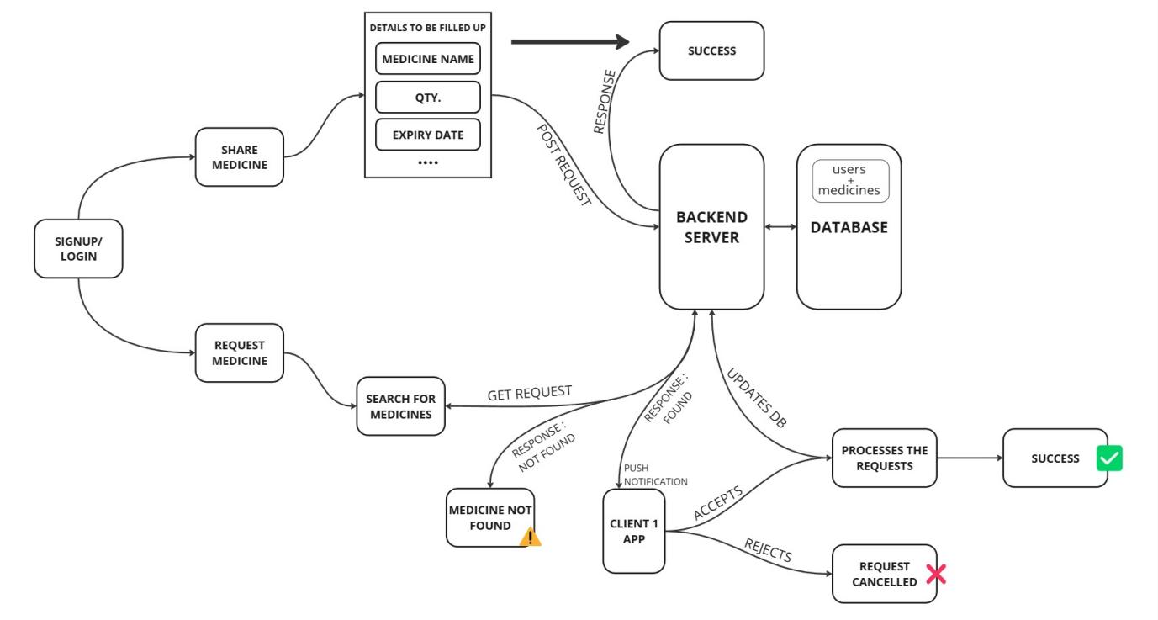

Fig. 1. Architecture Overview of MedShare App

* 1. **Timeline**

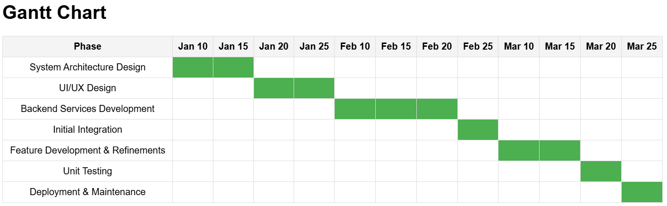

Table 1. Gantt Chart

* 1. **Organization of the Report**

**Chapter 1 - Problem Identification:** This chapter introduces the problem of limited access to essential medications during emergencies in campuses, residential areas, and similar environments. It discusses the challenges such as the unavailability of nearby pharmacies, restricted operational hours, and the lack of a reliable medicine-sharing platform. The MedShare app is proposed as a solution to address these issues by providing a peer-to-peer medicine-sharing framework for immediate access to basic medications.

**Chapter 2 - Literature Review:** This chapter examines previous studies and systems related to decentralized healthcare and medicine-sharing platforms. It also explores research on the impact of delayed access to medications in emergencies. Relevant statistics and frameworks are reviewed to highlight the gaps in existing systems and the need for such innovative, community-driven solutions like MedShare.

**Chapter 3 - Process:** This chapter outlines the systematic approach taken to develop MedShare, including the design of the system architecture, user interface (UI), backend services, and database management. It describes the methodology used, the integration of components, and the strategies for creating a seamless and secure platform. The chapter also details the iterative process of feature development and refinement based on user feedback.

**Chapter 4 - Result Analysis and Validation:** This chapter presents the results of testing MedShare for functionality, usability, and reliability. It discusses the app’s performance in simulated real-time emergency scenarios and its effectiveness in facilitating quick access to medications. Validation of the system through unit, integration, and usability testing is elaborated upon, with metrics to demonstrate the success of the proposed solution.

**Chapter 5 - Conclusion and Future Scope:** This chapter summarizes the outcomes of the MedShare project, highlighting its significance as a localized healthcare solution. It also addresses potential enhancements, such as adding advanced features like AI-based medication recommendations or partnerships with pharmacies. Future possibilities for expanding the app's scope to larger communities and integrating with existing healthcare systems will be discussed.

* 1. **References –**

[1] Y. Peng *et al.*, “Effectiveness of Mobile Applications on Medication Adherence in Adults with Chronic Diseases: A Systematic Review and Meta-Analysis,” *Journal of Managed Care & Specialty Pharmacy*, vol. 26, no. 4, pp. 550–561, Apr. 2020

[2] L. Dayer, S. Heldenbrand, P. Anderson, P. O. Gubbins, and B. C. Martin, “Smartphone medication adherence apps: Potential benefits to patients and providers,” *Journal of the American Pharmacists Association*, vol. 53, no. 2, pp. 172–181, Mar. 2013.

[3] A. J. Lazard, A. J. Saffer, L. Horrell, C. Benedict, and B. Love, “Peer‐to‐peer connections: Perceptions of a social support app designed for young adults with cancer,” *Psycho-Oncology*, vol. 29, no. 1, pp. 173–181, Sep. 2019.

[4] A. Plaza Roncero *et al.*, “Mobile Health Apps for Medical Emergencies: Systematic Review,” *JMIR mHealth and uHealth*, vol. 8, no. 12, Dec. 2020, doi: <https://doi.org/10.2196/18513>.

[5] Peng, Y., Wang, H., Fang, Q., Xie, L., Shu, L., Sun, W., & Liu, Q. (2020). Effectiveness of Mobile Applications on Medication Adherence in Adults with Chronic Diseases: A Systematic Review and Meta-Analysis. *Journal of managed care & specialty pharmacy*, *26*(4), 550–561.

[6] García-Sánchez, S., Somoza-Fernández, B., de Lorenzo-Pinto, A., Ortega-Navarro, C., Herranz-Alonso, A., & Sanjurjo, M. (2022). Mobile Health Apps Providing Information on Drugs for Adult Emergency Care: Systematic Search on App Stores and Content Analysis. *JMIR mHealth and uHealth*, *10*(4), e29985.

[7] Beyene, K. A., Sheridan, J., & Aspden, T. (2014). Prescription medication sharing: a systematic review of the literature. *American journal of public health*, *104*(4), e15–e26.

[8] H. Australia, “Pill Reminder and Medication Reminder,” *www.healthdirect.gov.au*, Feb. 21, 2023. https://www.healthdirect.gov.au/manage-medicine

‌